SECTION 1: BUSINESS CONTEXT
The background and problem for the dataset are in the global e-commerce and retail sector, facing the problem of stiff competition and very thin margins. In these departments, customers have countless choices, which makes it difficult to predict what factors results to higher sales. The analysis focuses on optimizing the revenues by identifying and paying attention to the factors that result in higher sales, without resource wastage through targeting revenue optimization incorrectly.
IMPORTANCE:
The information can be used by the management to maximize sales. Knowing what exactly would make an individual spend more on a single trip would help the stakeholders make informed decisions on what to stock more in order to achieve these high profits.
SECTION 2: RESEARCH QUESTIONS
1. Does a customer’s age or subscription status significantly predict how much they spend?
If age really determines how much a customer would spend, the business would probably need to advertise its products differently for different generations to make its operations effective.
2. Is there a significant difference between what customers spend on clothing and accessories?
What the customers delight in spending ought to be assumed to be more important as an inventory by the management. If there is no significant difference in the average spending on the departments, then the management should not pay more attention to one department and ignore the other.
3. Does customer satisfaction have any effect on financial return?
This determines whether the business should invest in customer satisfaction. If higher customer review result to higher spending, then the happiness of a customer is the direct revenue driver and should be greatly considered while serving them or while offering any services, more important than stocking valuable or cheap products.
SECTION 3: DATA ANALYSIS AND INTERPRETATION
Table 1: Linear regression table(Excel)
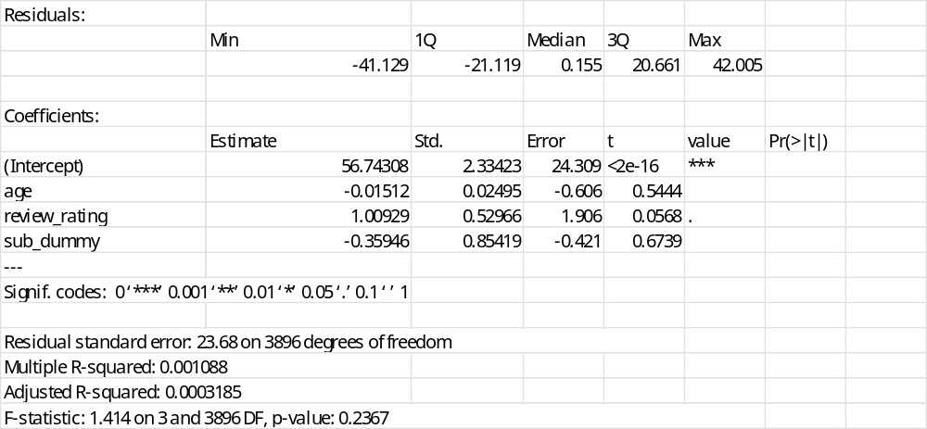
Review rating: The variable review ratings are the main variable of interest. The coefficient of 1.00929 translates to an increase of 1.01 dollars for every increase in one customer’s review ratings. The p-value of 0.0566 is slightly higher than the critical value of 0.05, and the variable is therefore statistically significant. The conclusion is that customer satisfaction is the key driver in revenues, with a positive trend being noted.
Customer’s age- The customer’s age has a p-value of 0.5444, which is way higher than the critical value. It is therefore statistically insignificant, and customers’ age does not predict how much or how little they will spend. It is therefore advised that strictly age-restrictive marketing segmentations should be avoided.
Subscription status - The subscription status has a p-value of 0.6739, which is also very high compared to the critical value. From this, it is not statistically significant, and therefore, being a subscriber does not guarantee higher spending.
Overall model strength- The variables in the model do not sufficiently explain the model. An R-squared of 0.0003185 indicates that the variables explain less than 0.0003185% of the purchase amount variations. The primary drivers of high purchases are therefore not captured in the model above.
Table 3:Categorical summaries in the clothing and accessories departments.
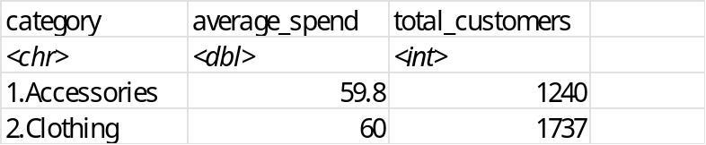
There is a consistent trend in spending, with the average spending on accessories being near the average spending on clothing (59.8 and 60.0) respectively. This means that regardless of what the customer is buying, each trip has a consistent budget. A total of 1737 customers on clothing and 1240 customers on accessories means that there are generally more transactions on clothing compared to transactions on accessories.

Table 4: Two-sample t-test for the 0.20 difference
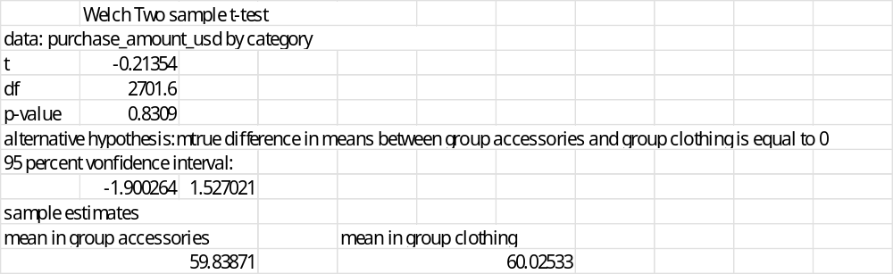
The two-sample t-test is conducted to investigate whether the 0.20-dollar difference in clothing and accessories is actually significant. The p-value of 0.8309 is way higher than 0.05, making it statistically insignificant. We can conclude that the average spending on clothing is equal to the average spending on accessories since the 0.20 dollars have no additional luck for the business. The management can therefore be notified that earning on both departments are equal.

Table 5: Effects of customer age on total spending.
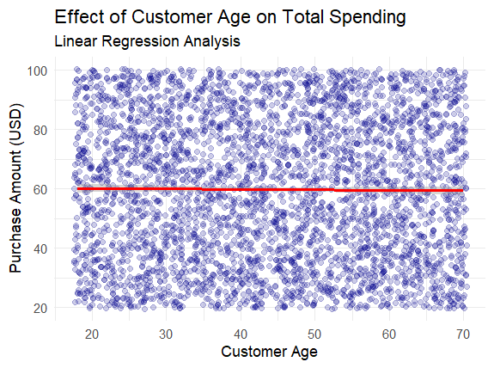

The average purchase amount averages to 60 dollars. The age of a customer does not affect the spending behavior of the customer. This is a confirmation figure for the linear regression output and the two-sample t-test results that the customer’s age is not significant in determining the amount of spending by an individual.
SECTION 4: INSIGHTS
The analysis reveals that for each trip, a customer gets in with an aim of spending 60 dollars, regardless of their age, nor is it determined by whether the customer is a member or not. The only thing that can change how much they spend is how satisfied they are, spending more with additional review of the business. The customers spend as much on accessories as the same as clothing. The business should therefore not worry about hw old their customers are, but should be considered to be selling matching sets to see if it is possible to earn 60 dollars twice at a go.

Clothing should not be attended to while ignoring accessories due to the difference noted, especially in determining the advertisement costs.
The business can try the double-up strategy by adding a matching set. Since the customers are comfortable spending on either department, a matching set not only adds a cheap item but also adds a bill of 60 dollars.

SECTION 5: RECOMMENDATIONS
From the analysis, membership and age are not significant in determining what a customer can spend on average. The business should therefore not have its concern on age or membership of the customers, but rather be concerned with their satisfaction. This comes from the additional possibility of spending 1.01 dollars for each additional customer review. The customers are comfortable spending an average of 60 dollars on either clothing or accessories for each trip. It is therefore advisable to invest equally in clothing and accessories in terms of advertisement, or get matching sets to earn an additional 60 dollars from the customers.

